- Create and manipulate factor variables (e.g., women’s dataset heights, random LETTERS sample).

Aim:
Create and manipulate factor variables (e.g., women’s dataset heights, random LETTERS sample).
Procedure:
Step 1: Open RStudio or R console on your computer.
Step 2: Create a character vector containing categorical values such as height levels. Step 3: Convert the character vector into a factor to represent it as categorical data.
Step 4: Display the factor to observe that R assigns internal numeric codes to each category.
Step 5: Set a random seed value to ensure that the random sampling results remain the same each time you run the program.
Step 6: Randomly generate a sample of leflers from A to E using the sample function.
Step 7: Convert the generated leflers into a factor to represent them as categorical variables.
Step 8: Print the factor to view the sampled categories and their assigned level
Program:
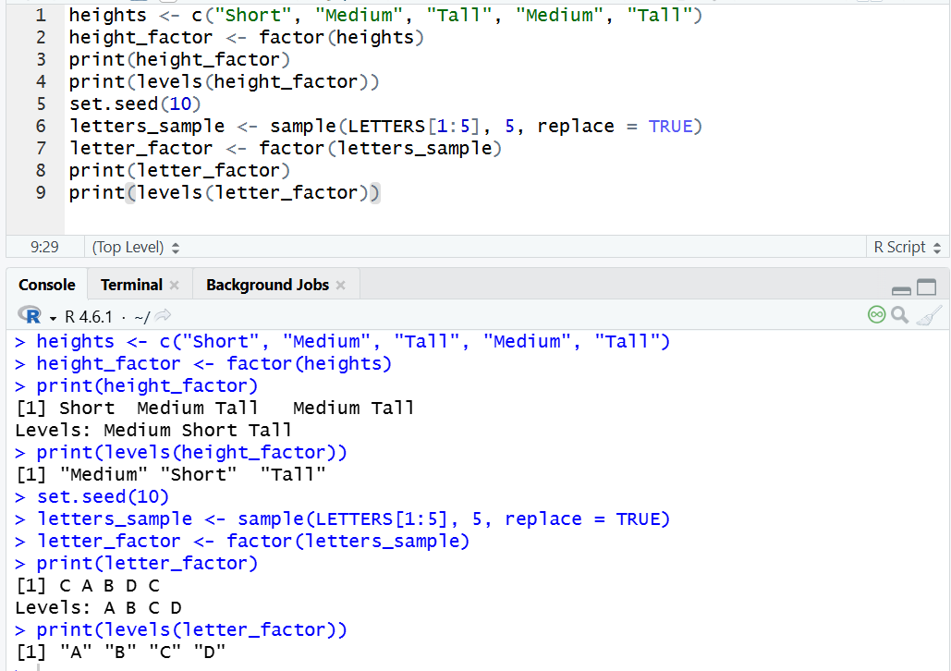
Result:
Hence the output is verified successfully.

